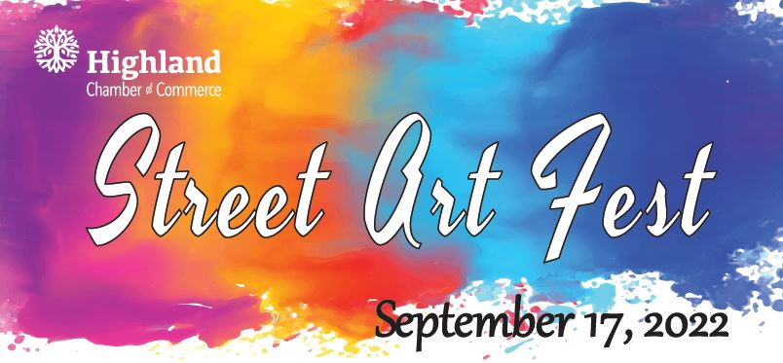
Our 2022 Street Art Artists!

Allie Wallace
Amy Simmons
Andrew Heffron
Ariel Ward
Carole Clayton
Casey Lohman
Catie Whitworth
Chris Ebl
Courtney Sellers
Craig Thomas
David Carr
Jill Schrage
Joshua Heffron
Karen Whaley
Kathryn Comish
Kortney Matthews
Lynn Kohlbrecher
Marissa Bowman
Mark Heffron
Mary Heffron
Mia Poe
Mikalyn Marburger
Megan Vinson
Meghan Whaley
Orion Galligos
Reagan Adolph
Sam Campos
Sarah Hoffman
Shyla Hibbs
Simon Menz
Stephanie Heffron
Susan Wellen
Susie Dewaele
Sydney Wellen
Sylvie Carroll
Zachary Heffron

